ENCHANTING INDIA-NEPAL TOUR (13Nts / 14 Days)

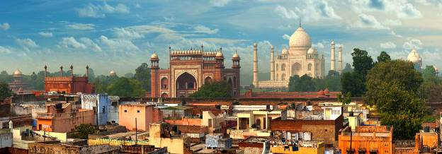

Day 01 ARRIVE DELHI

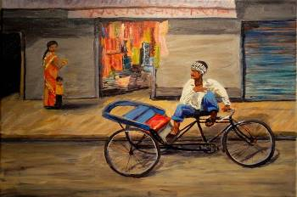
Welcome to the capital of India- Delhi. Meeting and assistance on arrival at Delhi international airport by our office representative who will you to the hotel. Once you will reach your hotel our representative will handover you the travel documents and explain your entire plan in details.

Delhi, City of Djinns, and 25 million people. Like an eastern Rome, India’s capital is littered with the relics of lost empires. A succession of armies stormed across the Indo-Gangetic plain and imprinted their identity onto the vanquished city, before vanishing into rubble and ruin like the conquerors who preceded them. Modern Delhi is a chaotic tapestry of medieval fortifications, Mughal mausoleums, dusty bazaars, colonial-era town planning, and mega malls.
Time free to relax & unwind after a long flight.

Overnight stay at hotel

Day 02 DELHI - SIGHTSEEING

Morning after breakfast city tour of Old Delhi – visiting Jama Masjid; the largest mosque of India with a courtyard capable of holding 25,000 devotees. It was begun in 1644 and ended up being the final architectural extravagance of Shah Jahan.

After that drive pass by Red Fort & take a Rickshaw ride in Chandni Chowk; one of the oldest and busiest markets in Old Delhi, built in the 17th century by Mughal Emperor Shah Jahan and designed by his daughter Jahan Ara. Thereafter visit the Raj Ghat; the black marble platform where Mahatma Gandhi was cremated in 1948 AD.
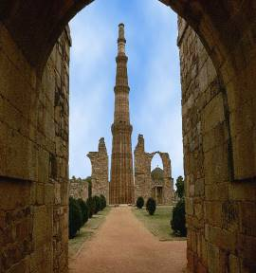
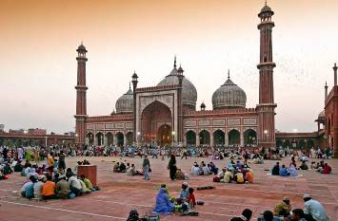

Afternoon visit Qutub-Minar; the red and buff sandstone is the highest tower in India. It has a diameter of 14.32 m at the base and about 2.75 m on the top with a height of 72.5 m. The tall minaret was constructed in 1192 by Qutab-ud-din Aibak, and later completed by his successor Iltutmish.

Evening visit the Lutyens Delhi to take pictures of beautiful building of British era; the Presidential House, Parliament and India Gate; the memorial bears the name of more than 13516 British and Indian soldiers killed in the 1st World War near the frontier of Afghan in 1919 AD.

Overnight stay at hotel

Day 3 DELHI- AGRA (215KMS/04HRS)

Morning after breakfast, proceed to Agra

Agra is a city on the banks of the river Yamuna- the city of Agra is synonymous with the Taj Mahal-one of the Seven Wonders of the World, renowned for its beauty and historical significance. Apart from being an important capital city to the Mughals during their rule, Agra also finds mention in the Mahabharata, where it was called Agrevana- which meant "The Border of the Forest". It is believed that the city was founded by Raja Badal Singh, a Rajput king, who's fort Badalgarh, stood on or near the present city.

Arrive Agra, Check in to hotel

Late afternoon visit Mehtab Bagh Garden for a Sunset view of Taj Mahal across Yamuna River.
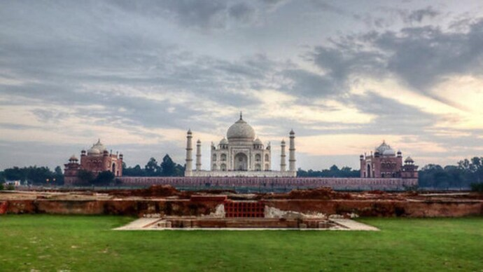

Time free to relax & unwind.

Overnight stay at Hotel.

Day 4 AGRA–JAIPUR (235KMS/05HRS)

Morning after breakfast visit of the world famous Taj Mahal a monument of love built by Shah Jahan as a memorial for his wife, Mumtaz Mahal, an incredible 20,000 workman’s labored on it, day and night. The construction of the Taj Complex began about 1631 AD. The principal mausoleum was completed in 1648 AD by employing thousands of artisans and craftsmen, whereas, the outlying buildings and gardens were finished five years later in 1653 AD.
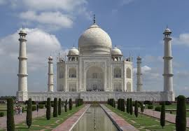
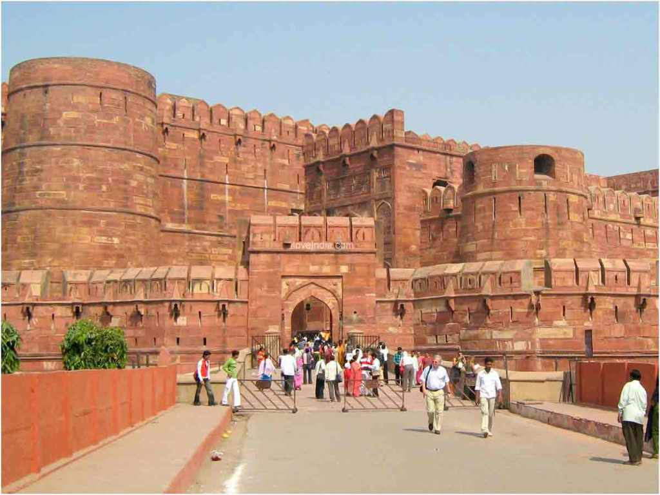
Afternoon visit Red Fort.
Red Fort or popularly known as Lal Quila was built by three generations of Mughal emperors, between 1565 and 1573. It housed both the residential palaces of the Royal family and the military quarters.

Afternoon drive by surface to Jaipur

Jaipur, the ‘Pink City’, has been the capital of erstwhile Jaipur state since its inception in 1727 AD, It was founded by Sawai Jai Singh II, a great ruler as well as renowned mathematician and astrologer. Vidhyadhar Bhattacharya, designed Jaipur as per the Hindu treatise, Shilp Shastra. In 1876 Jaipur dressed itself in pink to welcome Prince Albert, consort of queen Victoria, and earned the epitaph ‘Pink City'.

Time free to relax & unwind.

Overnight stay at hotel

Day 5 JAIPUR

Morning after breakfast drive to visit Amber Fort (11 kms away from city), Amer, originally, was the capital of the state before Jaipur. It is an old fort, built in 1592 by Raja Man Singh.

Enjoy the adventure of Local Jeep ride for uphill & downhill journey.

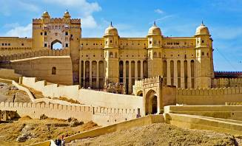
On way back to Jaipur, photo stop near Jal Mahal to take the beautiful pictures a small palatial building in the midst of the lake.
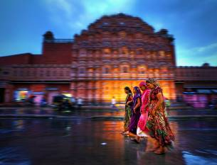
Make another photo shoot stop for an exterior of Hawa Mahal (the Palace of the winds).
Hawa Mahal consists of five tiers of corridors on the inside, with pierced screen windows of 956, which overlook the street below. It is believed the women of the royal zenana would sit concealed behind these screens to see life in the city beyond the walls of the palace.

Return back to Hotel for relaxing.

Afternoon, proceed for sightseeing of Pink City.
Visit Jantar Mantar; a stone observatory, part of the city palace complex, Jantar Mantar is one of several other astronomical observatories created by Maharaja Sawai Jai Singh II. These concrete masonry instruments were used to measure everything from altitude to time, and map the movement of the planets and the stars.

Later visit the City Palace & museum; the complex lies at the heart of the city. Getting in is simpler than it once was. At the heart of the complex is seven-tiered Chandra Mahal where the erstwhile royal family is still in residence, though only a small part of the apartments are occupied. However, it is only the buildings around Chandra Mahal that are open to the public, and these also form part of a museum which includes everything from Grand outfits (including one with 18 kilos of golden thread woven into it) to swords and two silver urns that are believed to be the largest silver objects in the world.

Overnight stay at hotel

Day 6 JAIPUR - DELHI (265KMS/05HRS)(\

After a relaxed breakfast, you are free to explore the Pink city on your own.
Afternoon check out & drive straight to Delhi.
On arrival, transfer to your pre-booked Hotel.
Check In at Hotel.

Time free to relax & unwind.
Overnight stay at Hotel.

Day 7 DELHI – KATHMANDU BY FLIGHT

After breakfast, transfer to airport to board flight to Kathmandu
As your flight lands in the beautiful valley of Kathmandu, our representative will receive you at the airport & transfer to your pre-booked Hotel.
Check In at Hotel.

Time free to relax & unwind.
Overnight stay at Hotel.

Day 8 KATHMANDU – SIGHTSEEING

After Breakfast, full day sightseeing tour of Kathmandu Valley.

Today we will visit Boudhanath (the second largest Buddhist stupa in the world) and Pashupatinath (one of the most significant Hindu temples of Lord Shiva in the world, located on the banks of the Bagmati river). (Although only Hindus are allowed to enter the temple, visitors can clearly see the temple and the activities performed in the temple premises from the eastern bank of the Bagmati river),

Later visit Swayambhunath stupa on top of hillock overlooking Kathmandu Valley.
Also visit, Kathmandu Durbar Square, an overwhelming frenzy of art and architecture. In Kathmandu Durbar Square, you will visit Hanuman Dhoka, Degu Taleju Temple, Kumari Temple and Maru Ganesh Shrine.

Return back to your Hotel.

Overnight stay at Hotel.
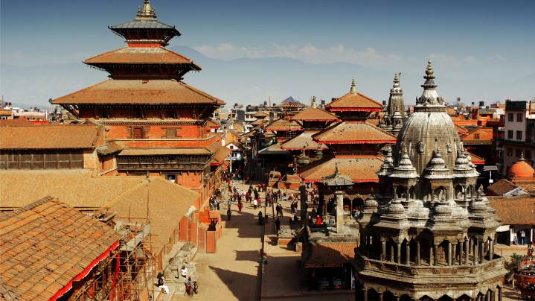

Day 9 KATHMANDU – SIGHTSEEING

After Breakfast proceed to visit Patan, the oldest and second large of the three cities in Kathmandu valley. It likes to recall its old name as Lalitpur (city of beauty). Afternoon visit Bhaktpur Darbar Palace.

Return back to Hotel,

Overnight stay at Hotel.
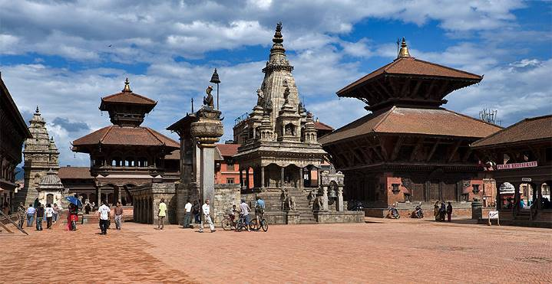

Day 10 KATHMANDU – POKHARA BY FLIGHT

After a relaxed Breakfast, Check Out & board 25 minute long flight to Pokhara.

Pokhara is a city besides beautiful Phewa Lake, in central Nepal. It’s known as a gateway to the Annapurna Circuit, a popular trail in the Himalayas.
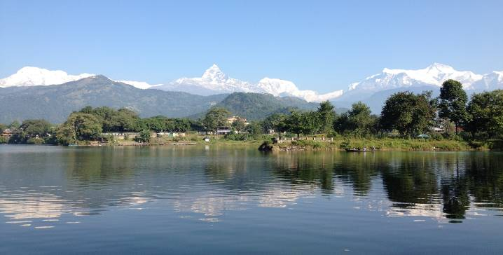
Proceed for full day sightseeing of Pokhra visiting Davis fall, Gupteshwar Cave, Tibetan Refugee Camp, World peace Stupa, International Mountain museum, Bindabashini Temple along with Boat ride in Phewa Lake.
Evening free to enjoy a short walk around the main street in Pokhara, which is bustling market with Restaurants & Souvenir Shops.

Overnight stay at Hotel.

Day 11 POKHARA – KHANDE BY CAR & TREK TO AUSTRALIAN CAMP

Early Breakfast at Hotel.
Check out with minimal luggage & proceed to Khande (01 hrs drive).
On the way, we’ll go by a large Tibetan camp at Hyanjha which is famous for local handicraft and Tibetan carpet weaving.

Dhampus-Australian Camp Easy Trek for families is an ideal trek package for those who are looking for an enriching holiday experience in Nepal with their children. It is a short and easy trek to experience the rich nature and culture of the Annapurna region which serves exceptional views of the Annapurna massif and Machhapuchhre Himal (6993m), allowing you and your family to create beautiful memories.
Arrive Khande & start Hike to Australian Camp (2232 Mtrs / apporx 3 Hrs).
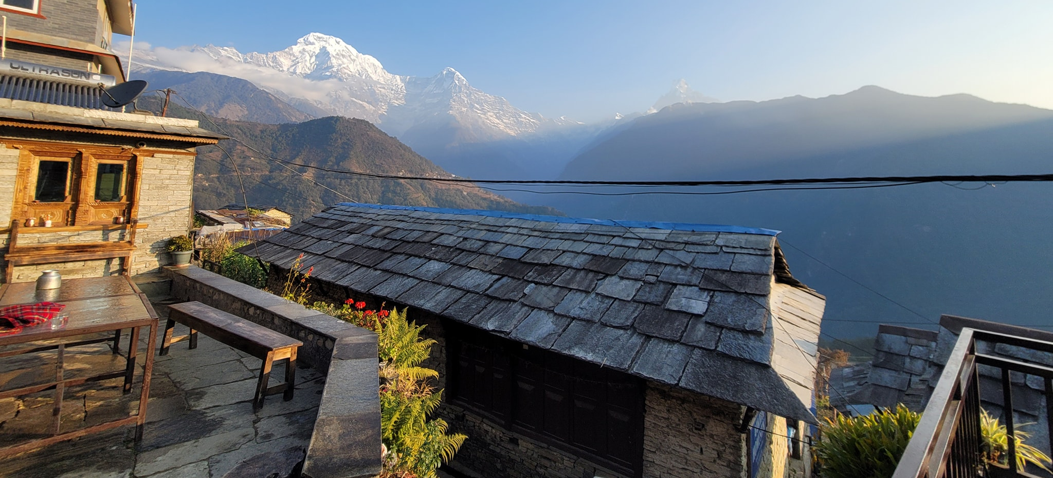

Australian camp is center of the Dhampus hill range from where one can see amazing Jungle scenery and similar views as Poonhill like Annapurna South, Fishtail, Mt Dhaulagiri,Tukuche peak, Dhampus Peak, Nilgiri and Himchuli.
Enjoy a relaxing time enjoy the beauty of majestic Himalayan ranges.

Overnight stay at Lodge / Tea House.

Day 12 AUSTRALIAN CAMP - TREK DOWN TO DHAMPUS / PHEDI - POKHARA

Early morning enjoy a Sunrise view on the Annapurana Himalayan Range.
Breakfast at lodge
Australian Camp – Trek to Dhampus (1650 Mtrs / 1hrs).
Dhampus is beautiful village with a number of slate-roofed houses, paved countrysides and a Buddhist monastery. The trek is ideal for those wishing to experience Nepali mountain scenery and ethnic culture within a short time.

Dhampus to Phedi by down trek (02hrs) and then drive by car to Pokhara (45 min)

On arrival check in at Hotel. Day at leisure
Overnight stay at Hotel.

Day 13 POKHARA – KATHMANDU BY FLIGHT

After your breakfast, Check out & transfer to airport for flight to Kathamandu.
Arrive & check in at Hotel.

Afternoon free for last minute shopping wherby you may visit the bustling Thamel Market & look for some souvenirs & can have a traditional Nepali meal also.
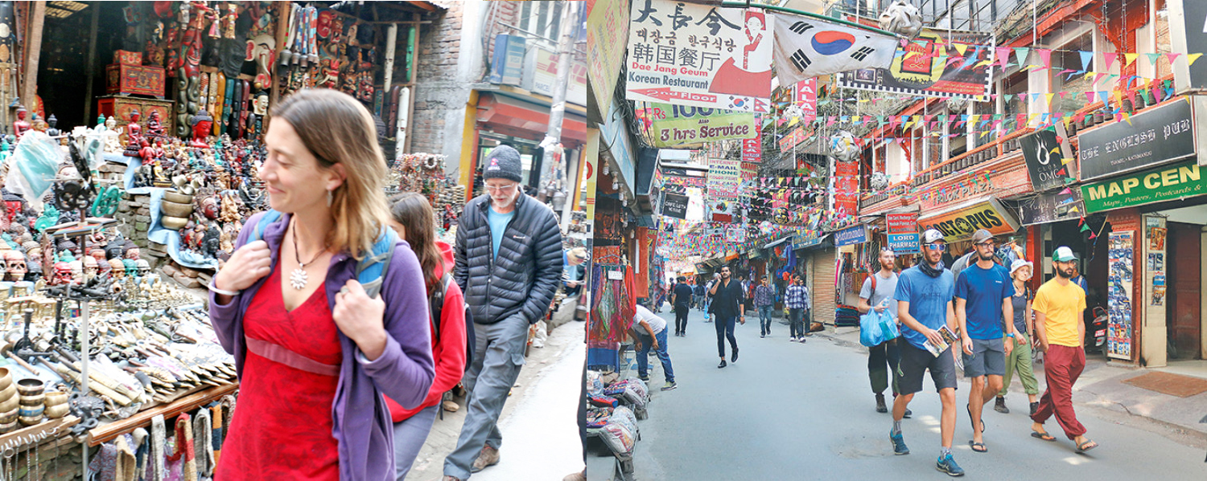
Time at Hotel to pack your bags before final departure.

Overnight stay at Hotel.

Day 14 KATHMANDU - DEPARTURE

In time transfer to airport with assistance to board flight back home.

End of the Tour


