Wheels of Thunder – The Paro Loop Bhutan Motorbike Expedition 8D/ 7 N

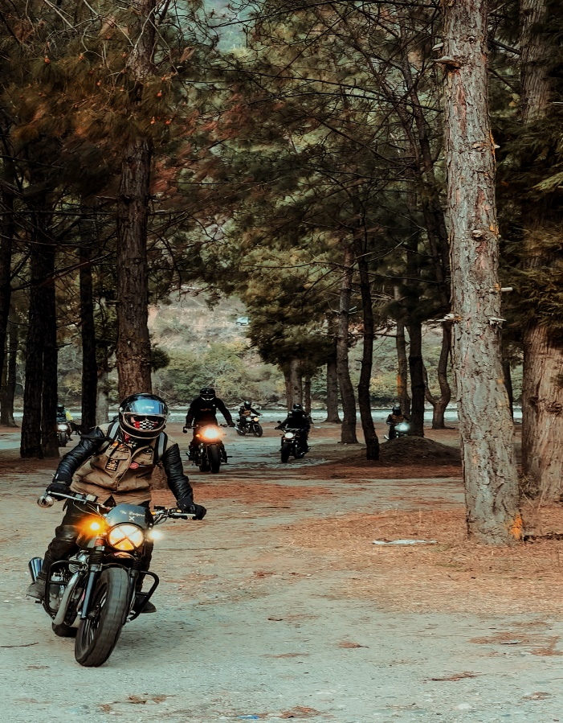
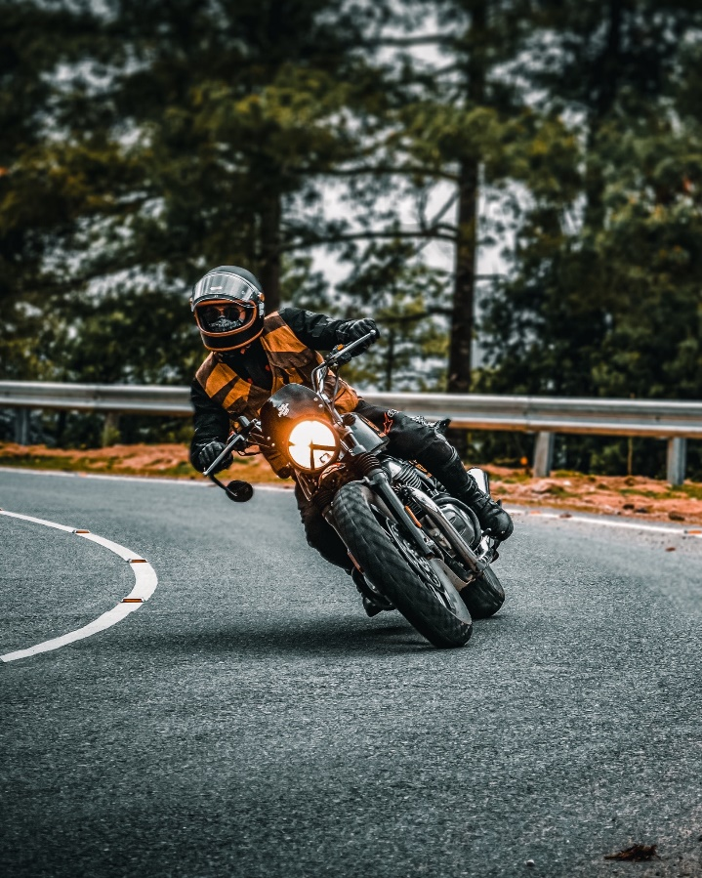

Kuzuzangpo La- Hello and Welcome to the Land of the Thunder Dragon
The Kingdom of Bhutan is located high in the Himalayas. Bordering in the north to Tibet in China and to the South to India.
The roof of the world is about the size of Switzerland (46,000 sq Kilometer) and has a population of app. 700,000. The country features 20 districts and the elevation is between 1500 and 7000 meters. In general, life and movements happen in elevation zones of 2000 to 4000 meters. Bhutan is truly blessed with spectacular scenery, gentle people and is the only country in the world that has a negative carbon emission. Great pride is being taken to continue to be the world leader in sustainability and grow sustainably. That is why success in Bhutan is not measured in financial terms but with the gross national Happiness Index.
The British Author, who has mentioned Shangri-La (paradise on Earth) as it is assumed to be a fictional place. Maybe he wrote about Bhutan? For many that have travelled to Gem, it has become their very own Shangri-La.
Ride on the ideal motorbike for this country and terrain the Royal Enfield. Speed is not of concern rather than the casual ride along spectacular scenery without feeling bad about the environment. We will emit much less the other in their cars and truly see Bhutan through the eyes of a native.

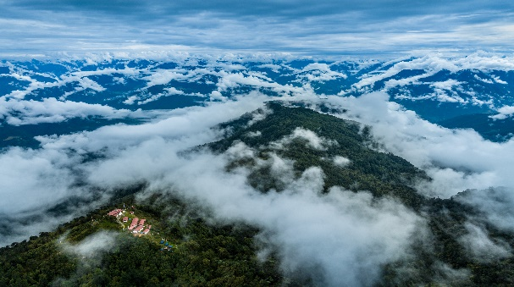
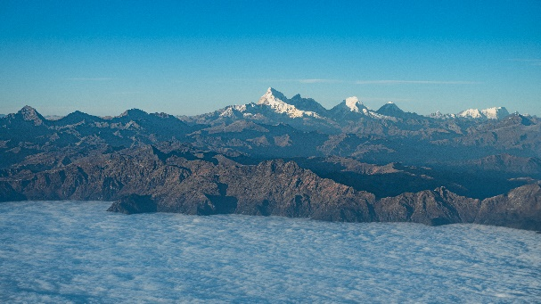

🗺 Itinerary Overview
- Duration: 8 Days / 7 Nights
- Bike: Royal Enfield Classic 350 / 500
- Total Distance: ~1,000 km
- Max Altitude: ~3,988m (Chelela Pass)
- Ride Intensity: Moderate to Challenging
- Start/End Point: Paro ➝ Paro

Day 1: Arrival in Paro – Acclimatization & Test Ride

- After a friendly welcome at Paro International Airport, transfer to the Hotel, completion of the motorbike paperwork and instructions on riding in Bhutan, we will go on a familiarization ride.
Distance: ~20 km (easy valley loop)
- Ride Hours: ~1.5 hrs
- Ride Highlights: Gentle local ride to get used to the bikes
- Activities:
  - Briefing on riding in Bhutan, safety protocols
  - Local loop ride to Dzongdrakha Cliff Temples or Airport Viewpoint
  - Visit Paro Dzong or relax at a traditional Bhutanese farmhouse
- Stay: Tashi Namgay Resort or Metta Resort, Paro
- ✅ Best Add-on: Traditional hot stone bath in the evening (Optional)
Included: Airport welcome and transfer to the hotel, Motorbikes, fuel, guide, hotel and lunch and dinner. Water for along the ride.

Day 2: Paro ➝ Haa via Chelela Pass ➝ Thimphu (via Old Haa-Thimphu Road)

- Distance: ~180 km
- Ride Hours: ~8 hours
- Ride Highlights:
  - Cross Bhutan’s highest motorable road (Chelela Pass – 3,988m)
  - Explore remote Haa Valley
  - Ride along the scenic old Haa-Thimphu road through villages, forests, and riversides
- Activities:
  - Visit Lhakhang Karpo & Haa town
  - Lunch picnic by the Haa river
- Stay: Osel Hotel or Tashi Yodling hotel, Thimphu
- ✅ Best Add-on: Coffee stop at a local café run by youth entrepreneurs in Thimphu
Included: Breakfast, Motorbike, Fuel, Guide, Water along the way, Pic Nic Lunch and Dinner, Hotel
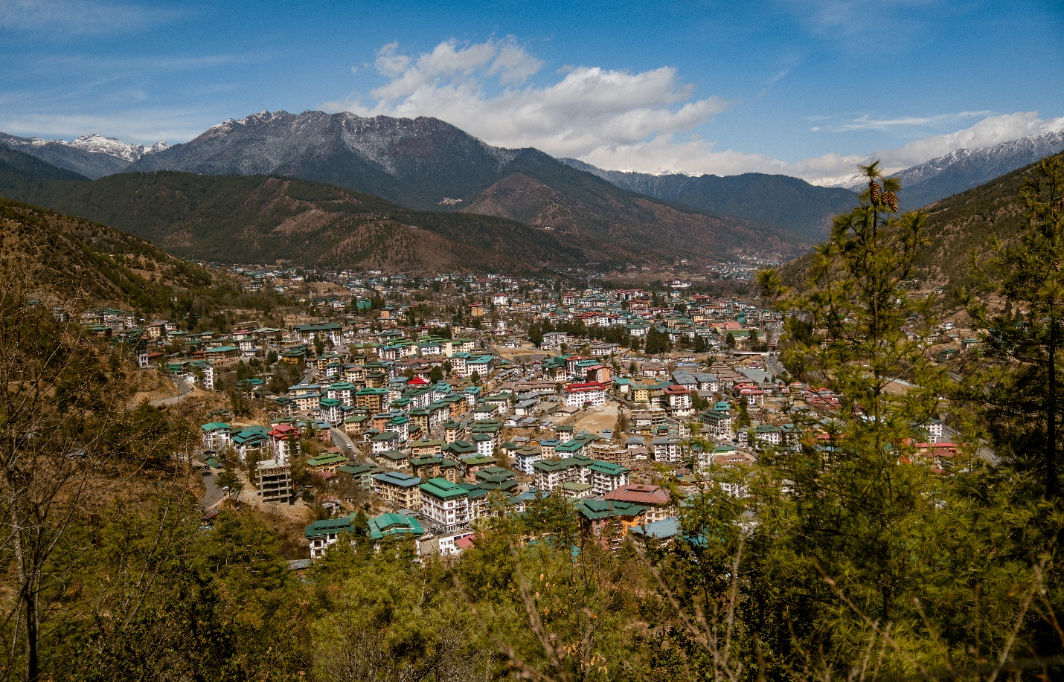

Day 3: Thimphu ➝ Dochula Pass ➝ Punakha ➝ Phobjikha Valley

- Distance: ~155 km
- Ride Hours: ~6 hours

- Ride Highlights:
  - Stunning 108 chortens at Dochula Pass (3,100m)
  - Mountain, pine forest, and rice paddy terrain
  - Misty entry into Phobjikha glacial valley
- Activities:
  - Visit Dochula Pass & Druk Wangyel Lhakhang
  - Punakha Dzong and suspension bridge
  - Gangtey Monastery visit on arrival in Phobjikha
- Stay: Gakidling resort or abc lodge, Phobjikha
- ✅ Best Add-on: Evening nature walk in black-necked crane habitat
Included: Breakfast, Motorbikes, Fuel and Guide, Water along the way, Lunch and Dinner Overnight at the Hotel.
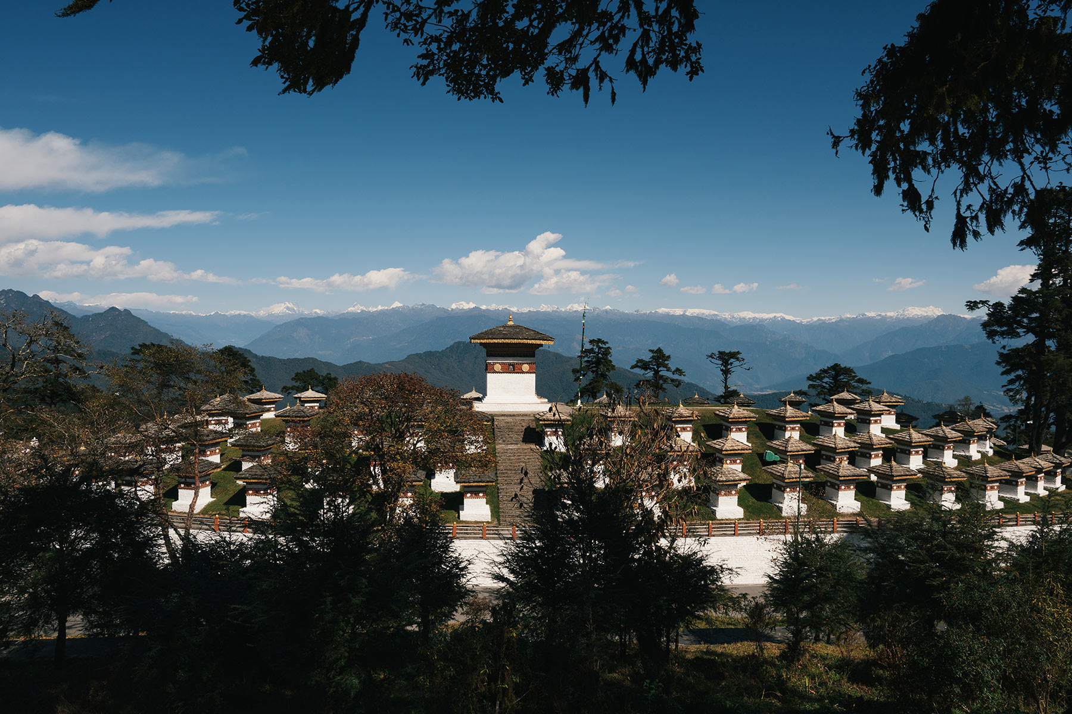

Day 4: Phobjikha ➝ Trongsa ➝ Bumthang

- Distance: ~180 km
- Ride Hours: ~5 hours

- Ride Highlights:
  - Ride across Pele La Pass (3,420m)
  - Endless winding mountain roads with panoramic views
- Activities:
  - Stop at Chendebji Chorten
  - Explore Trongsa Dzong en route
- Stay: Swiss Guest house, Bumthang
- ✅ Best Add-on: Try local beer at Red Panda Brewery or a cultural dinner
Included: Breakfast, Motorbikes and fuel, Guide, Water along the Way, Lunch and Dinner and overnight at the hotel
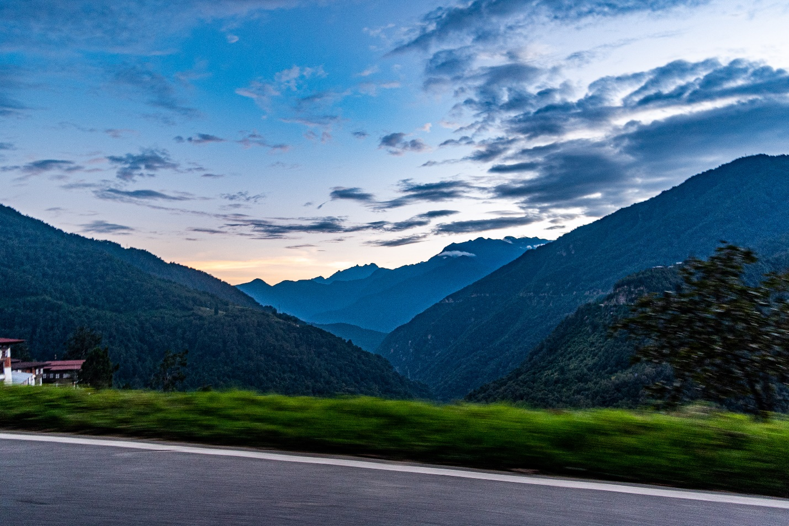

Day 5: Bumthang ➝ Tang Valley ➝ Return to Bumthang

- Distance: ~90 km
- Ride Hours: ~3 hours

- Ride Highlights:
  - Serene and lesser-known Tang Valley
  - Best highland biking scenery and traditional homes
- Activities:
  - Visit Ugyen Choling museum
  - Interact with local villagers
- Stay: Swiss Guest house, Bumthang
- ✅ Best Add-on: Visit Mebar Tsho (Burning Lake)
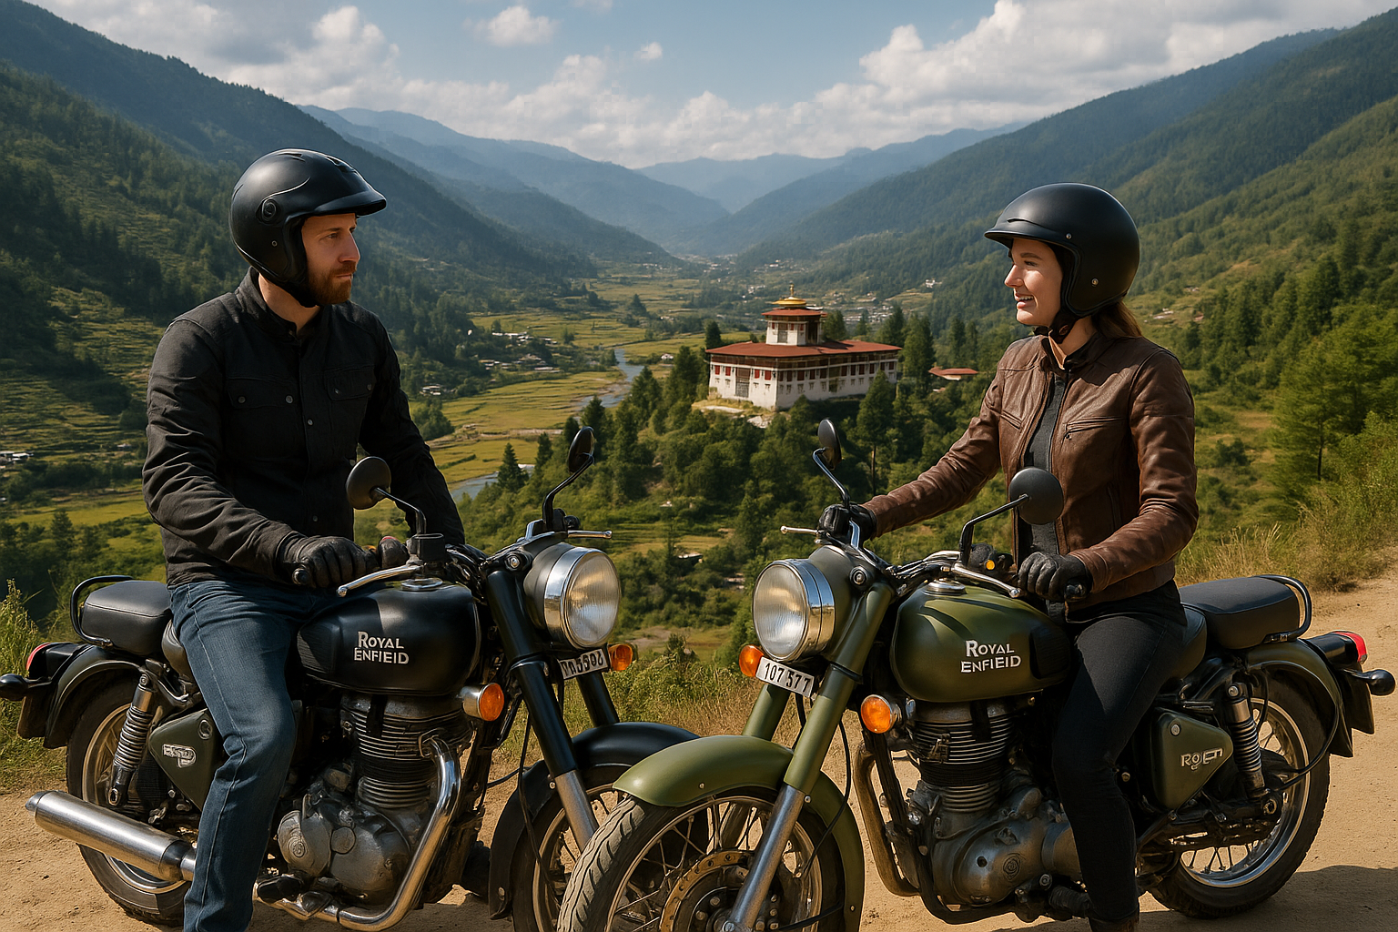
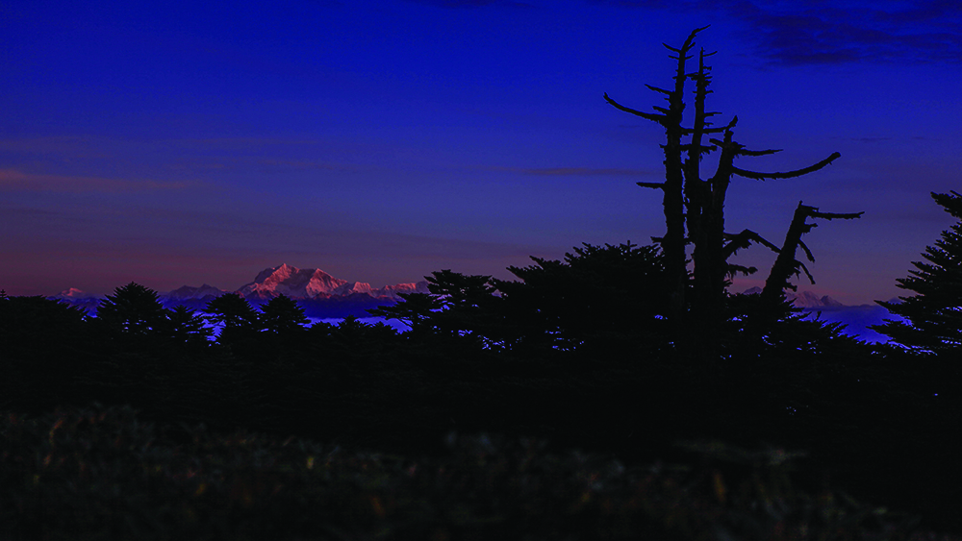
Included: Breakfast, Motorbike and Fuel, Guide, Water along the Way, Lunch and Dinner overnight at the Hotel Museum entry fee

Day 6: Bumthang ➝ Trongsa ➝ Wangdue ➝ Paro

- Distance: ~316 km
- Ride Hours: ~10 hours

- Ride Highlights:
  - Longest ride day, crossing central Bhutan end-to-end
  - Forest roads, river valleys, dzongs, and chortens
- Activities:
  - Refreshment stops in Trongsa & Lobesa
  - Lunch in Wangdue / near Punakha
- Stay Tashi Namgay Resort or Metta Resort, Paro
✅ Best Add-on: Group celebration dinner with local music or storytelling
Included: Breakfast, Motorbike and Fuel, Guide, Water along the Way, Lunch and Dinner, overnight at Hotel.
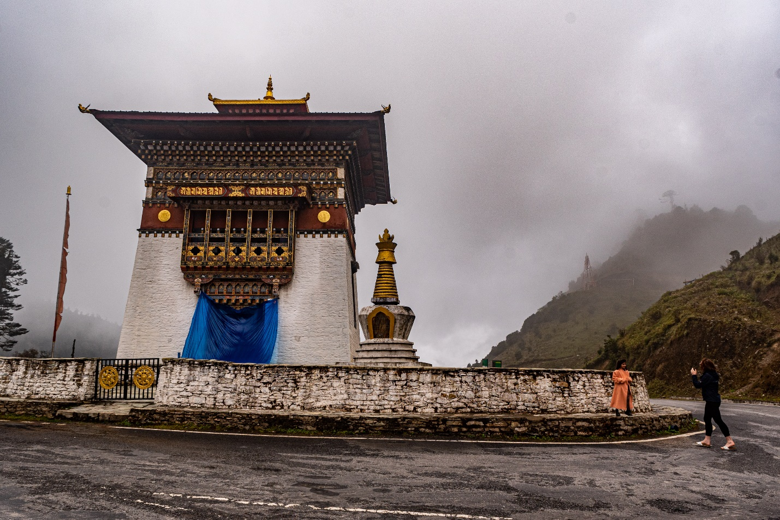

Day 7: Hike to Tiger’s Nest Monastery (Paro Taktsang)

- Distance: ~4 km hike (one-way)
- Ride Hours: ~1 hour

- Ride Highlights: Park bikes at the trailhead
- Activities:
  - Hike to one of Bhutan’s most iconic landmarks perched on a cliff
  - Meditate at the monastery, reflect on the journey
- Stay: Tashi Namgay Resort or Metta Resort, Paro
✅ Best Add-on: Optional massage after the hike
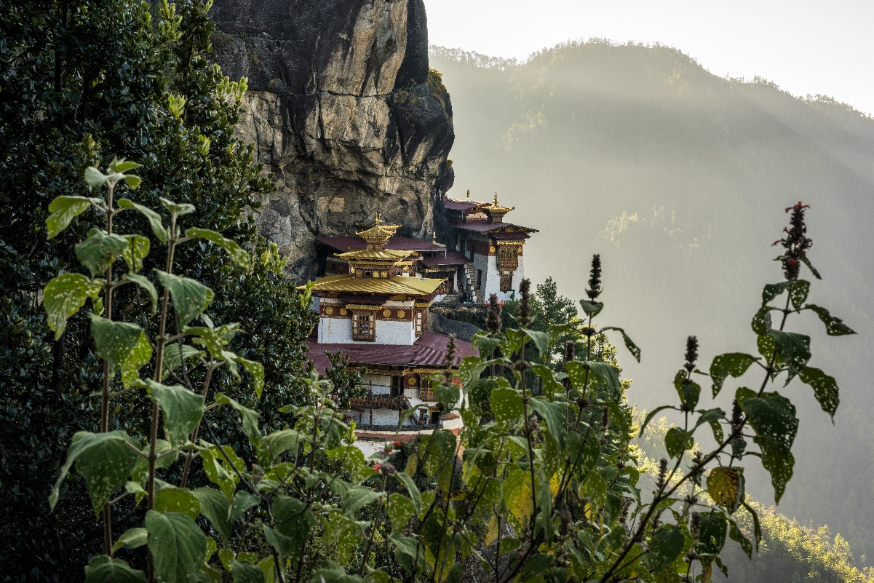
Included: Breakfast, Motorbike and Fuel, Guide, Water along the Way, Lunch and Dinner, over night at Hotel.

Day 8: Departure
- Activities:
  - Souvenir shopping or short cultural visit depending on flight time
  - Airport transfer
- ✅ Farewell gift idea: Provide a framed group photo or Bhutanese good luck charm

Included: Breakfast, Transfer to paro Airport and a hearty farewell to your extraordinary journey on the Paro Loop.

📊 Tour Summary
Feature | Details
Total Distance | ~1,000 km
Ride Days | 6 Ride Days + 1 Hike
Max Elevation | 3,988m (Chelela Pass)
Best Season | March–May / Sept–Nov
Ride Difficulty | Moderate to High
Riders per Group | 6–10 (ideal size)

Prices:
Based upon double occupancy: USD: Auf Anfrage
Pillion Rider based on room double occupancy: USD Auf Anfrage
What is included:
- Royal Enfield 350 or 450cc Motorbike Rental fee
- Fuel
- Guide
- Hotels and Breakfast, Lunch and Dinner as outlines in the Itinerary
- Drinking Water for along the way
- Entry to Museums
- Visa Fee US 40.-
- Dailly Sustainability Fee of US 100.- per person
- Support Vehicle with Service Technician
The tour prices below: do not include the following:
- Single room supplement of USD 180.-(optional)
- Airfare to and from Bhutan
- Travel insurance (required)
- Other personal expenses like overseas calls, laundry, alcoholic beverages, souvenirs
- Tips for the driver and tour guide
- Anything not listed in the Tour Program
- Pony to the Halfway Rest Stop at the Tigers Nest US 30 per Pony

Please ask for our Group Prices, 6 riders plus are a group.
Payment:
50% at the time of booking
50% 30 days prior to arrival to Bhutan
Cancellation Policies:
30 days prior to departure no refund
45 days prior to departure 25% refund
60 days prior to departure 50% refund
61 + days prior to departure full refund

TOUR PLAN
May change subject to weather and road conditions, at the discretion of the tour guide. Suitable alternatives will be provided.
Photo Credits: Bhutan Department of Tourism and Studio Khonsu @Adam Slama
IMPORTANT :
While travelling to offbeat & remote areas, there are many variables beyond our control like weather conditions, landslides, road situations and any other force majeure conditions.
Circumstances amounting to "force majeure" include any event which we or the supplier of the service(s) in question could not even with all due care, foresee or forestall such as (by way of example and not by way of limitation) natural disasters, fire and health risks, acts of God, unavoidable and unforeseeable technical problems with transport / flight for reasons beyond our control or that of our suppliers, closed or congested airports and other actual or potential adverse weather conditions, and any other similar events. In such situations we might be forced to change the itinerary.

For further information please contact:

Head Office:
Himalayan-ecotrails
Kawang zur Lam, Kawajangsa
Thimphu, 11001 Bhutan
Phone: +975-17721043
E-Mail: hello@himalayan-ecotrails.com


European Office:
Bierhausstrasse 28
1712 Tafers, Switzerland
Phone: +41 76-792-2427
E-Mail: hello@himalayan-ecotrails.com

Our Partner Keksconsulting KLG

