MYSTIC HIMALAYAS: SIKKIM & DARJEELING DISCOVERY 11 NIGHTS & 12 DAYS

This enriching 12-day journey through India’s North East begins with your arrival in Delhi before flying to Bagdogra and exploring the serene hills of Kalimpong and vibrant Gangtok in Sikkim.
Witness the majestic Changu Lake and Baba Mandir before heading to the remote high-altitude villages of Lachen and Lachung, where you'll marvel at the pristine beauty of Gurudongmar Lake and Yumthang Valley, known as the Valley of Flowers. The journey continues with scenic drives through lush landscapes to Gangtok and onward to the picturesque town of Pelling, where ancient monasteries and natural wonders await. Conclude your Himalayan adventure in Darjeeling with sunrise views from Tiger Hill and visits to iconic local landmarks, before flying back to Delhi for a brief city glimpse or relaxation before departure.

Map:

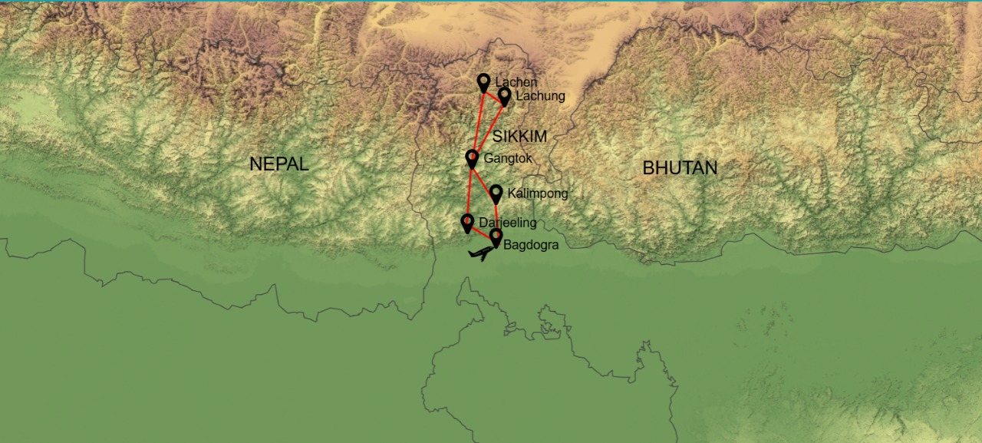

Itinerary:

Day 01: Arrive Delhi

Meet & assistance on arrival & transfer to Hotel.
Overnight stay at Hotel.

Day 02: Delhi / Bagdogra (IXB) By Flight – Drive to Kalimpong (77 kms in 2-3 hrs)

Early Breakfast at Hotel. In time transfer to airport to board flight for Bagdogra. Arrive Bagdogra & transfer to Kalimpong (1,205 Mtrs / 4091 ft.).
On arrival check in to hotel & rest of the day at leisure.

Kalimpong has a rich and fascinating history that dates back centuries. The area around present-day Kalimpong was originally inhabited by the Lepcha and Bhutia communities and still reflects their cultures. The name 'Kalimpong' itself comes from the Lepcha word 'Kalim-pung,' which translates to 'flat lands'. Present day Kalimpong is a melting pot of diverse cultures, colonial British, Bhutanese and Tibetan influences. It has a resilient spirit that has withstood the test of time. This rich tapestry of stories and experiences adds to the town's allure and makes it a truly captivating destination for travellers.
Overnight stay at Kalimpong.

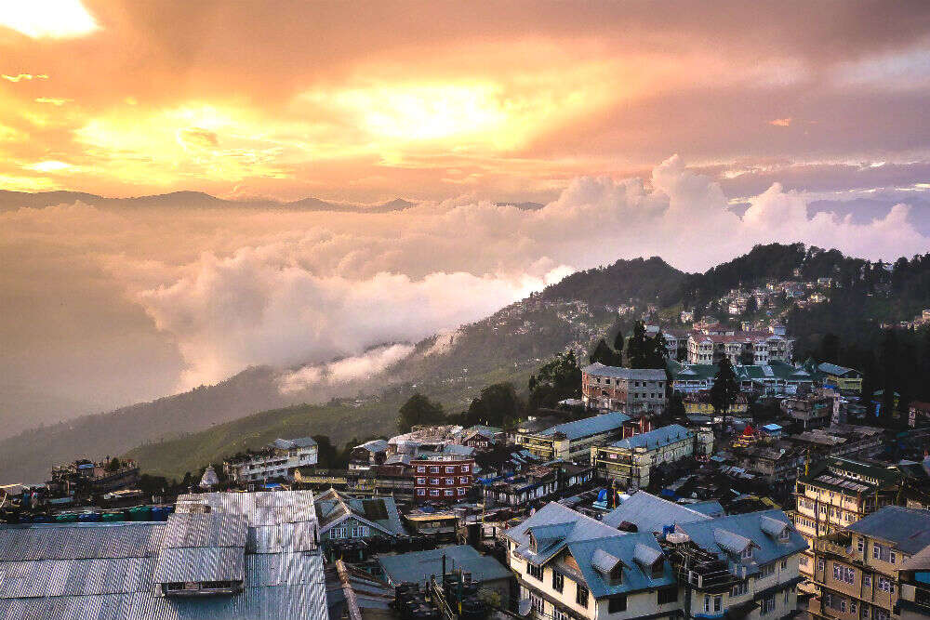

Day 03: Kalimpong Local Sightseeing – Gangtok (77 kms / 3 hrs)

After relaxed Breakfast, proceed for a relaxed half day tour of Kalimpong - Visit Mangal Dham, Deolo Hill, Dr. Graham’s Home, Golf Garden, Durpin Dara Hills & Flowers Nurseries.
Afternoon transfer to Gangtok (5,480 ft.), Capital of Sikkim. On arrival check-in to your hotel.
Evening at leisure.
Overnight stay at Gangtok.
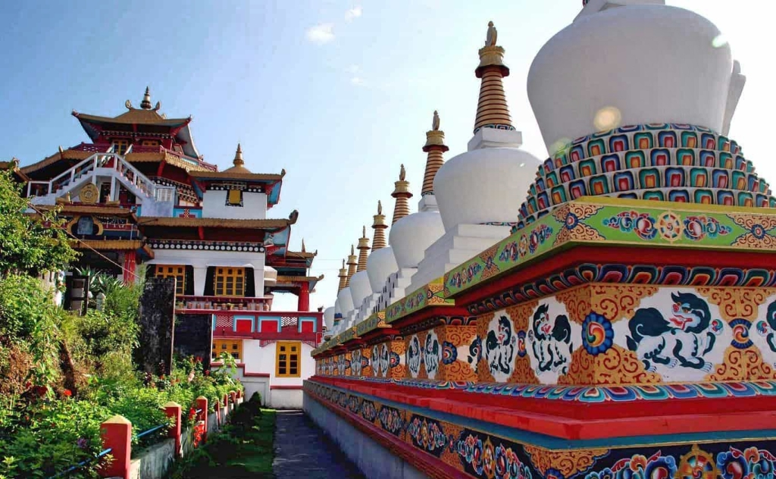

Day 04: Excursion to Changu Lake & Baba Mandir

After breakfast start for an excursion to Changu Lake (12,400 ft.) & Baba Mandir (13,200 ft.) which is 55 kms from Gangtok city each way (Starts 7:30 AM – 3:30 PM).
Enjoy the scenic drive through winding mountain roads surrounded by alpine trees and snow-capped peaks.
On return, stop at Kyongnosla Waterfall for quick photos before heading back to your hotel.
Evening at leisure to stroll in the Gangtok Market.

Overnight stay at Gangtok.

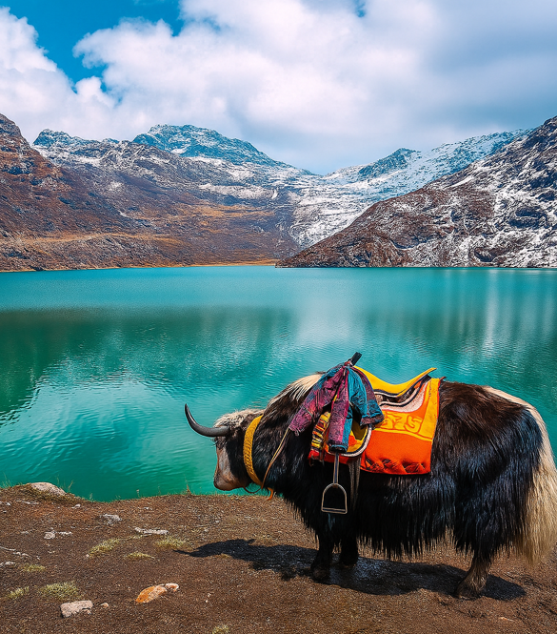

Day 05: Gangtok – Lachen (125 kms / 6 hrs)

After breakfast pick up from hotel & transfer to Lachen (9,285 ft.).
Enroute visit Singhik View point, Seven Sister Water Fall, Naga Water Fall, and reach Lachen by evening.

Lachen is a town in North Sikkim known for its stunning natural beauty, serene atmosphere, and proximity to several popular tourist destinations. It's often called the gateway to Gurudongmar and Tso Lhamu lakes.
Lachen is also a base for exploring the Chopta Valley, Green Lake, and Shingba Rhododendron Sanctuary.
Dinner & Overnight stay at Lachen.
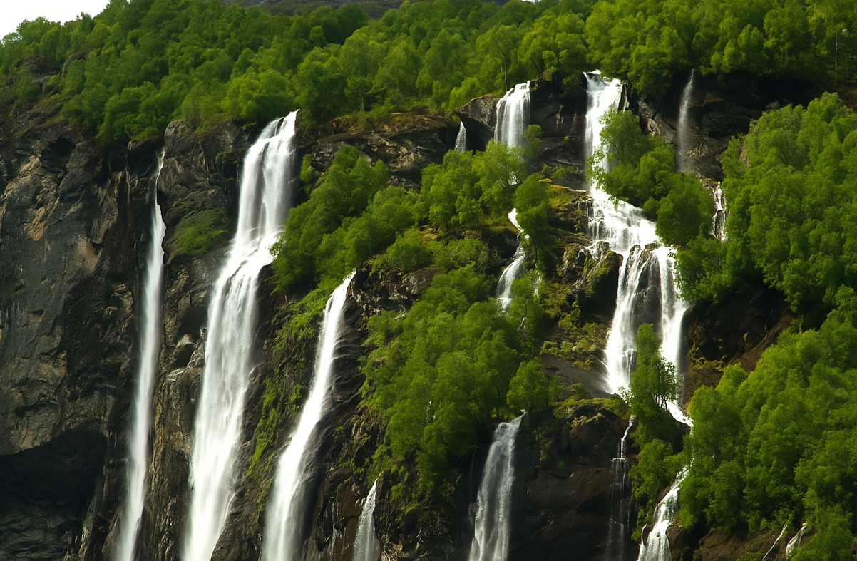

Day 06: Lachen - Chopta Valley – Gurudongmar Lake – Lachung

Early Morning drive to Chopta Valley (13,225 ft.) & Gurudongmar Lake (17,175 ft.).
Back to hotel. After Lunch check out & transfer to Lachung (8,175 ft). Reach Lachung by evening.

Dinner & Overnight stay at Lachung.

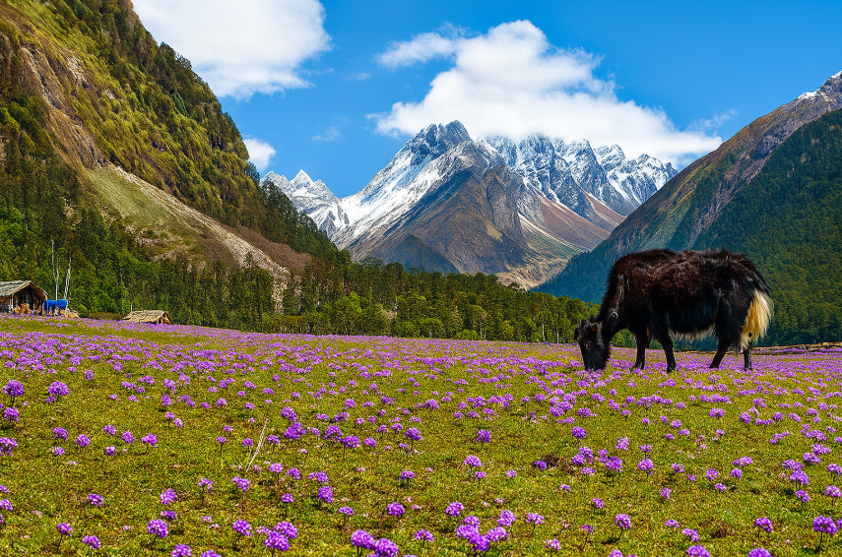

Day 07: Lachung – Yumthang Valley Excursion

Lachung, a picturesque town in North Sikkim, has a rich culture that blends Tibetan, Nepalese, and indigenous Sikkimese influences. Surrounded by lush green valleys, sparkling waterfalls, and vibrant rhododendron forests, Lachung is a nature lover's paradise.
After breakfast drive to Yumthang Valley Known as Valley of Flowers (11,910 ft.). On the way back, visit Hot Spring considered to have medicinal properties.
Return back to your Hotel.
Overnight stay at Lachung.
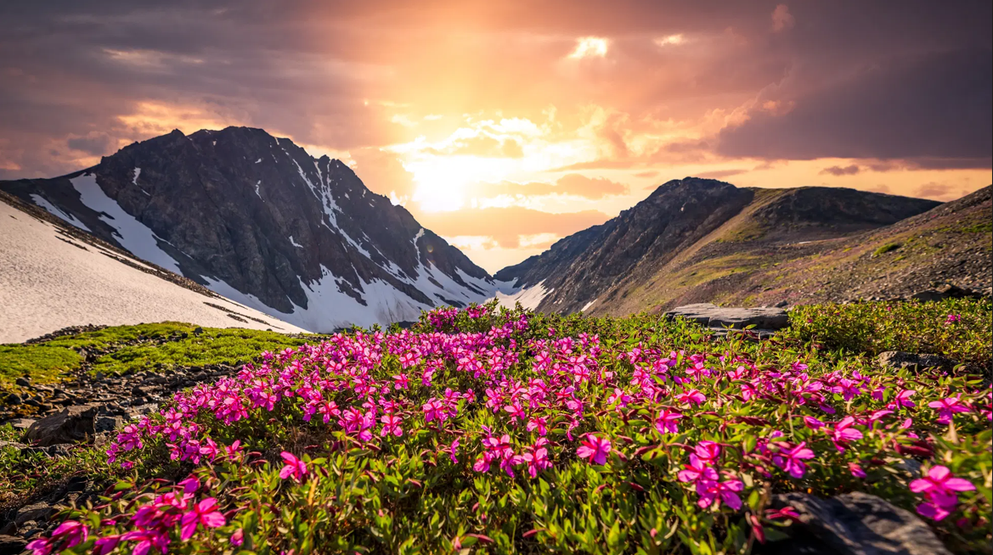

Day 08: Lachung - Gangtok (120 kms / 6 hrs)

After a relaxed breakfast departure for Gangtok (capitol of Sikkim), en-route witness the wonderful Bheema & Twin water falls. On arrival at Gangtok check-in to your hotel.
Evening at leisure.
Overnight stay at Gangtok.
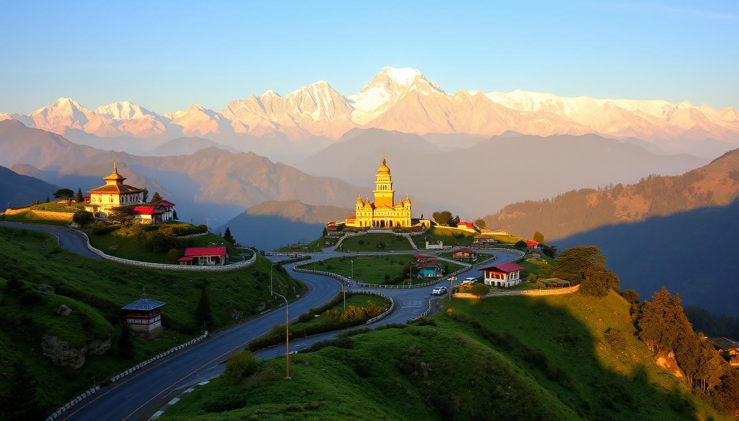

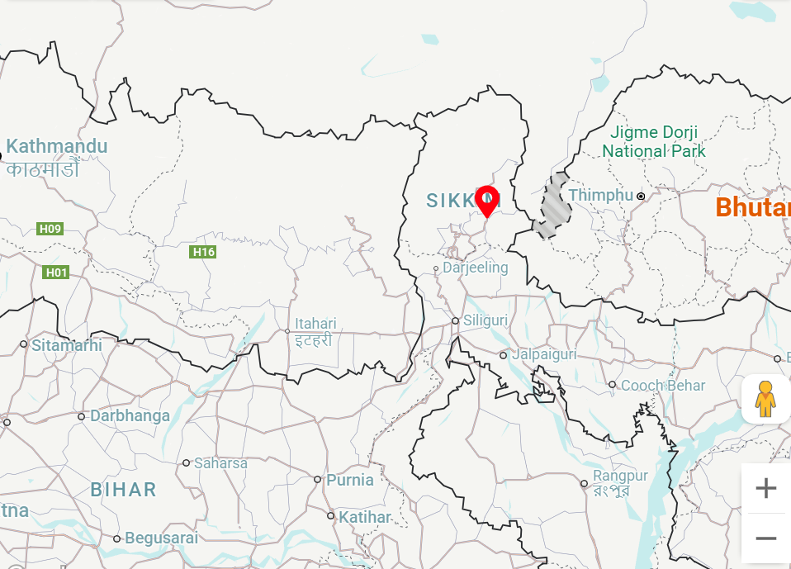

Day 09: Gangtok Local Sightseeing - Pelling (117 Kms / 5 hrs)

Gangtok is known as the ‘mystical jewel of the Eastern Himalayas’

As the first rays of the sun kiss the snow-capped peaks, casting a golden hue over the verdant valleys below, Gangtok awakens to a new day filled with promise and adventure. From its colorful Buddhist monasteries to its bustling markets and breathtaking vistas, Gangtok is a destination like no other – a symphony of sights, sounds, and sensations that will captivate your heart and soul from the moment you arrive.
This morning (Starts 8:30 AM – 1:00 PM) for a half day trip of Gangtok city covering Banjhakri Falls, Cottage Industry and Handicraft Centre, Flower show, Dro-dul Chorten & Institute of Tibetology. Afternoon transfer to Pelling (6,100 ft.).
Enjoy panoramic views of the hills and valleys as you descend from Gangtok to the charming town of Pelling.
Enroute, witness serene village life and lush greenery that line the winding mountain roads.

On arrival check-in to your hotel. Overnight stay at Pelling.
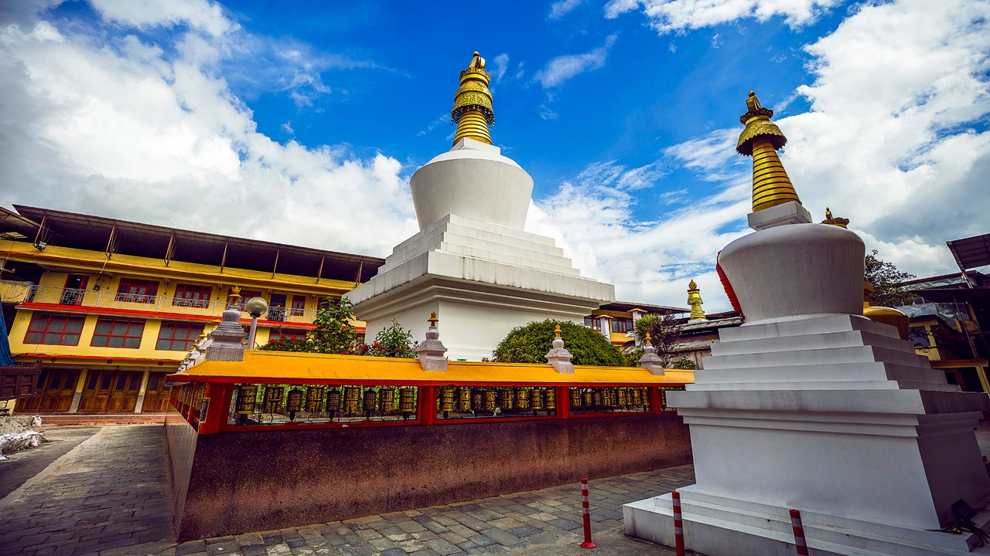

Day 10: Pelling Sightseeing

Pelling, a charming town in West Sikkim, India, offers stunning views of the Kanchenjunga range, the world’s third-highest mountain. Standing at an elevation of 2,150 meters (7,050 feet), Pelling is a haven for nature lovers and adventure seekers. The town beautifully captures the essence of Sikkim with its lush landscapes, cascading waterfalls, and rich cultural heritage.

After breakfast start for full day sightseeing (Starts 8:30 AM - 4: 30 PM) visit Darap village, Kanchenjunga waterfalls, Sewaro Rock Garden, Rimbi water Falls & Khecheopalri Lake.
After lunch visit Pemayangtse Monastery, Rabdantse Ruins, New Halipad Ground and Bird Sanctuary.
Overnight stay at Pelling.
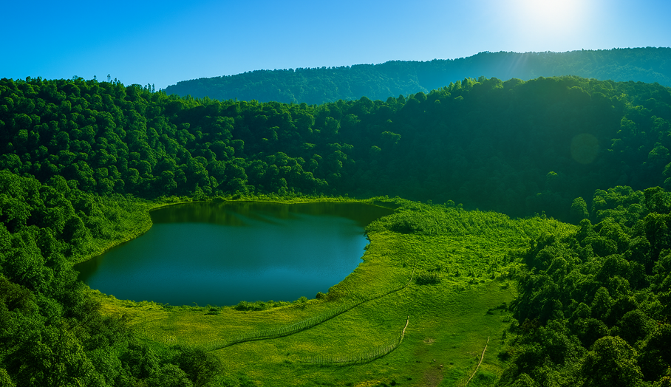

Day 11: Pelling - Darjeeling (80 kms /4 hrs)

This morning after breakfast transfer to Darjeeling (6,710 ft.), Enjoy scenic beauty of Rangeet River Valley on the way.
On arrival check-in to your hotel & rest of the day at leisure.

Overnight stay at Darjeeling.

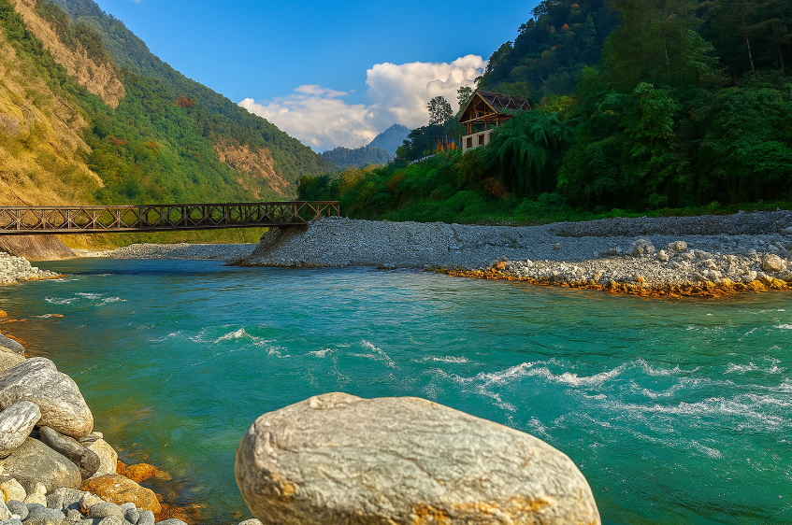

Day 12: Darjeeling Sightseeing

A cup of ‘Darjeeling Tea in hand’, a ride aboard the historic ‘Toy Train’ with a vista of the majestic Kanchenjunga in the timeless beauty of the Himalayas. There seems no better place to relax than Darjeeling. Tucked away amidst the lush tea plantations in West Bengal with colonial-era architecture and peaceful Tibetan monasteries defining its timeless charm, Darjeeling promises you a wealth of enchanting local traditions in the soothing environment of mist-covered mountains. Embrace the beauty, culture and flavours of Darjeeling, where aromatic tea comes together with heritage trains and local customs in the lap of nature.

Early Morning at 4:00 am drive to Tiger hill to watch the sunrise over Mt. Kanchenjunga (28,208 ft. Worlds 3rd highest peak), on your way back visit Ghoom Monastery and Batasia Loop.

After breakfast visit Himalayan Mountaineering Institute, Zoological Park (Thursday closed), Tenzing Rock, Tibetan Refugee self-help Centre (Sunday closed), Tea Garden (outerview) and Japanese Temple (4 hrs from 9.00 to 13.00 hrs). Evening free for shopping & leisure.

Overnight stay at Darjeeling.

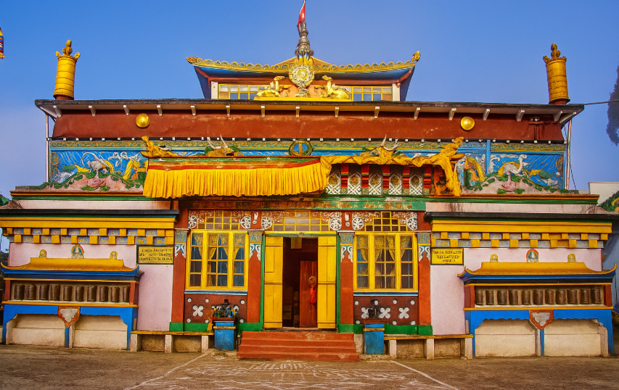

Day 12: Darjeeling– Drive to Bagdogra Airport (IXB) (98 kms / 3 hrs) FLY to Delhi

(If you wish you can spend one more day completely at leisure in Darjeeling or exploring the famous Tea Gardens of Darjeeling)

After an early breakfast check out from hotel and transfer to Bagdogra Airport to board flight for Delhi.
On arrival you can have a short orientation tour of Delhi before proceeding to Delhi International Airport to board flight back home.
Depending upon your Flight Departure time you may stay overnight in Delhi or take Rooms for Wash & Change near Airport.



