|  |
| --- |
| NEPAL Annapurna Base Camp Trek  12 DAYS (KTM IN / KTM OUT) |

**Discover the Famous Annapurna Base Camp Trek**

Join us on the amazing **Annapurna Base Camp Trek**, a popular adventure that attracts trekkers from all over the world. At 4,130 meters above sea level, the base camp offers incredible views of Mount Annapurna, which is the 10th highest mountain in the world at 8,091 meters. This trek takes you through beautiful mountains, friendly villages, and stunning scenery. It’s an unforgettable journey and a perfect way to experience the beauty of the Himalayas. Come and explore one of Nepal’s most famous trekking routes with us!

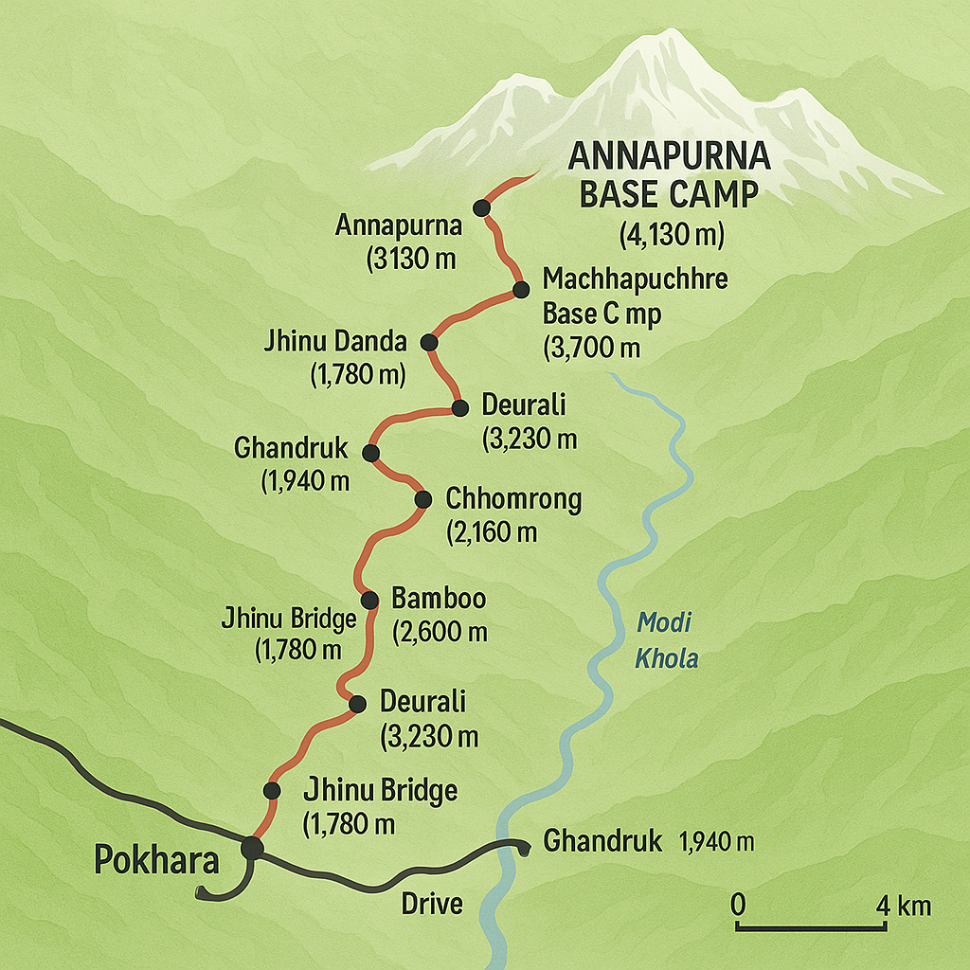

**TOUR ITINERARY:**

|  |
| --- |
| **Day 01: Arrive Kathmandu** |

Upon arrival at Tribhuvan International Airport, Kathmandu, you will be welcomed by our local representative holding a placard with your name.

After introduction, you will be transferred by private vehicle to your hotel.   
After check-in, relax and enjoy the rest of the day at leisure or stroll around the nearby **Thamel market.**

**Overnight:** Stay at Hotel Maya Manor Boutique, Kathmandu.  
**Meal:** No Meal

|  |
| --- |
| **Day 02: Fly Kathmandu to Pokhara (25 minutes)** |

Morning: After breakfast, transfer to the airport and board a short scenic flight to Pokhara, the city of lakes.

Upon arrival, check-in at the teahouse or hotel near **Phewa Lake.**  
Enjoy your afternoon at leisure with optional boat rides or lakeside cafés.

**Overnight:** Stay at hotel, Pokhara  
**Meals:** Breakfast

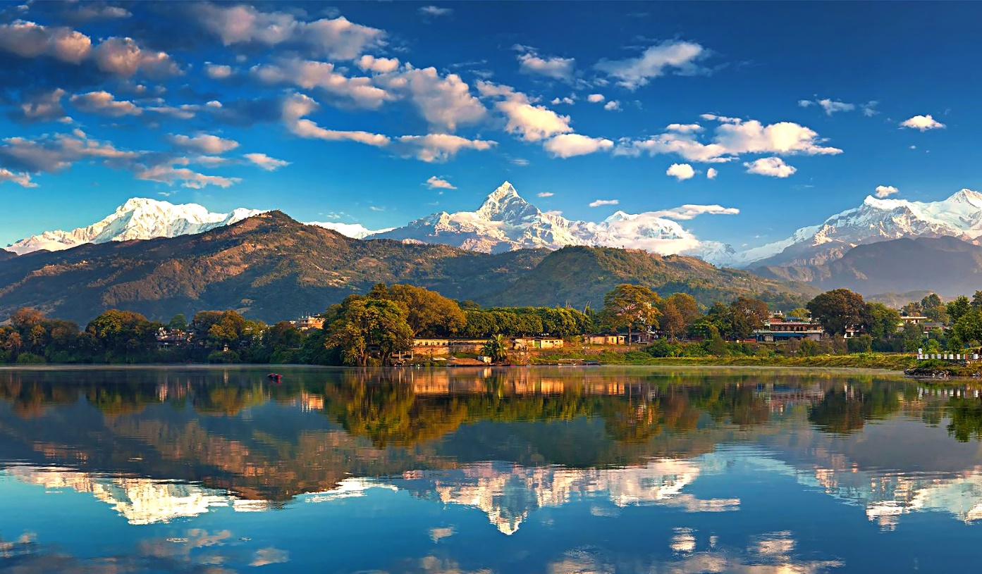

|  |
| --- |
| **Day 03: Pokhara – Drive to Ghandruk (55 km / 3–4 hrs)** |

Morning: After breakfast, drive through the picturesque countryside to Ghandruk, a charming Gurung village perched on a ridge with grand Himalayan views.

Afternoon: Explore the traditional village, visit the Gurung Museum, and acclimatize.

**Overnight:** Stay at a local teahouse in Ghandruk  
**Meals:** Breakfast, Lunch, Dinner

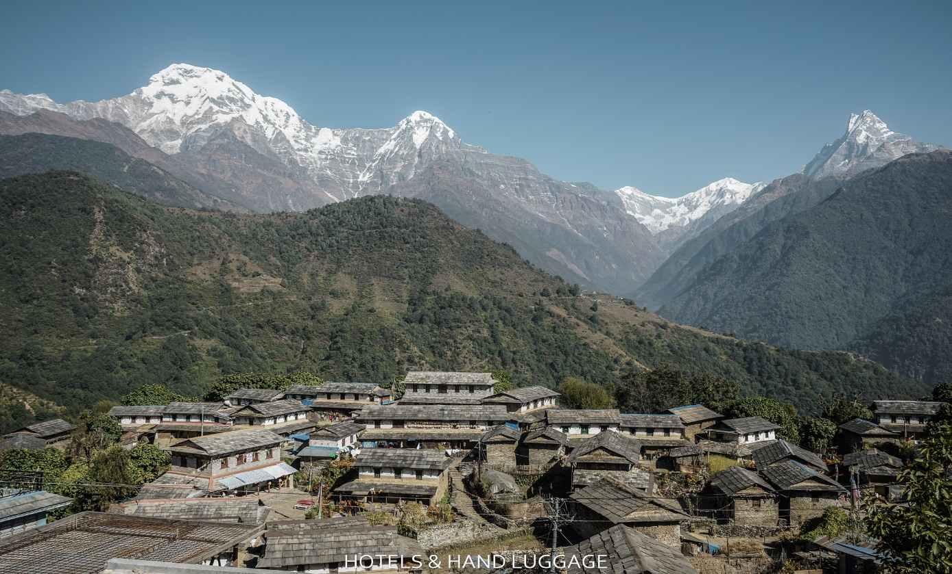

|  |
| --- |
| **Day 04: Trek Ghandruk to Chhomrong (2,170 m / 6–7 hrs)** |

Trek begins with a descent to the Modi Khola river followed by a steep climb through lush forests and stone stairways to reach Chhomrong.

Enjoy spectacular views of **Annapurna South and Hiunchuli.**

**Overnight:** Stay at a teahouse in Chhomrong  
**Meals:** Breakfast, Lunch, Dinner

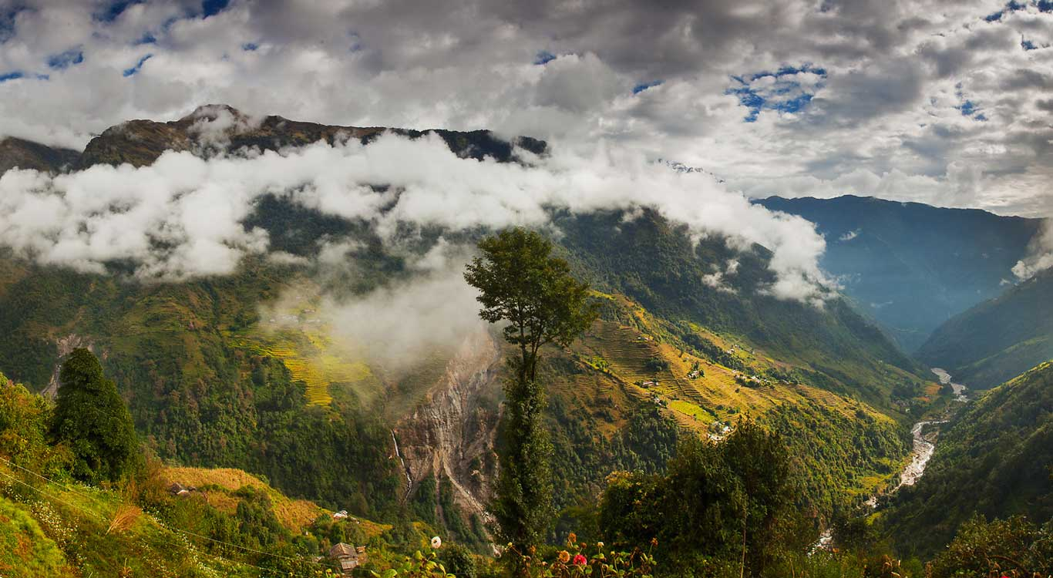

|  |
| --- |
| **Day 05: Trek Chhomrong to Dovan (2,600 m / 6 hrs)** |

Today’s trail descends to **Chhomrong Khola** and ascends through dense bamboo and rhododendron forests, passing Sinuwa and Bamboo villages before reaching Dovan.

**Overnight:** Stay at a teahouse in Dovan  
**Meals:** Breakfast, Lunch, Dinner

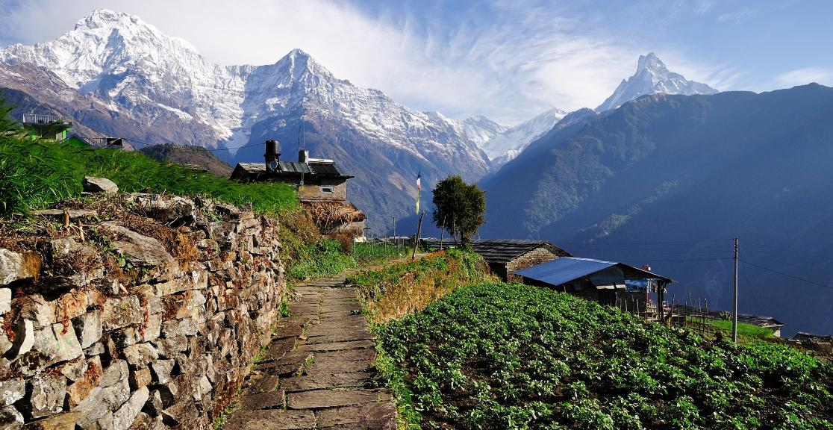

|  |
| --- |
| **Day 06: Trek Dovan to Deurali (3,230 m / 5 hrs)** |

Continue trekking through mossy forests and narrow gorges.  
Cross **Hinku Cave** and reach **Deurali**, where the valley opens up with mountain views.

**Overnight:** Stay at a teahouse in Deurali  
**Meals:** Breakfast, Lunch, Dinner

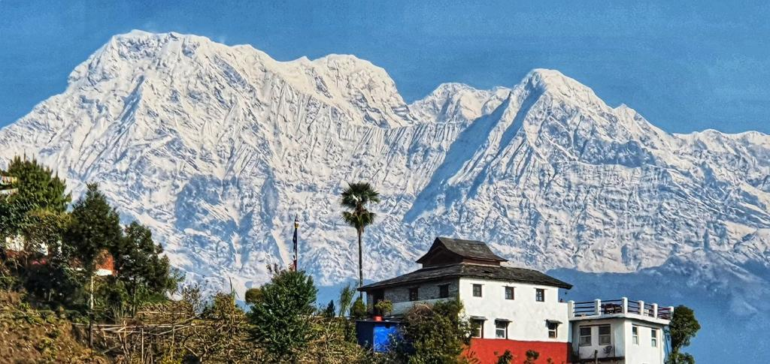

|  |
| --- |
| **Day 07: Trek Deurali to Annapurna Base Camp (4,130 m / 6 hrs)** |

Start early and climb past **Machhapuchhre Base Camp (MBC)** with panoramic views of the sacred “**Fishtail**” peak.

Arrive at Annapurna Base Camp – surrounded by a circle of mighty Himalayan giants.

**Overnight:** Stay at a teahouse at Annapurna Base Camp  
**Meals:** Breakfast, Lunch, Dinner

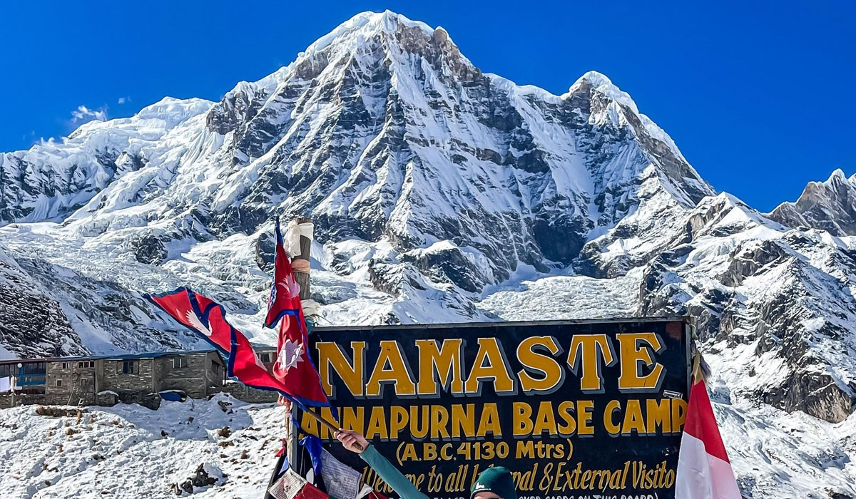

|  |
| --- |
| **Day 08: Trek ABC to Bamboo (2,310 m / 6 hrs)** |

Witness a glorious sunrise over the Annapurna range before retracing your steps down to Bamboo.

A long descent, but less physically demanding.

**Overnight:** Stay at a teahouse in Bamboo  
**Meals:** Breakfast, Lunch, Dinner

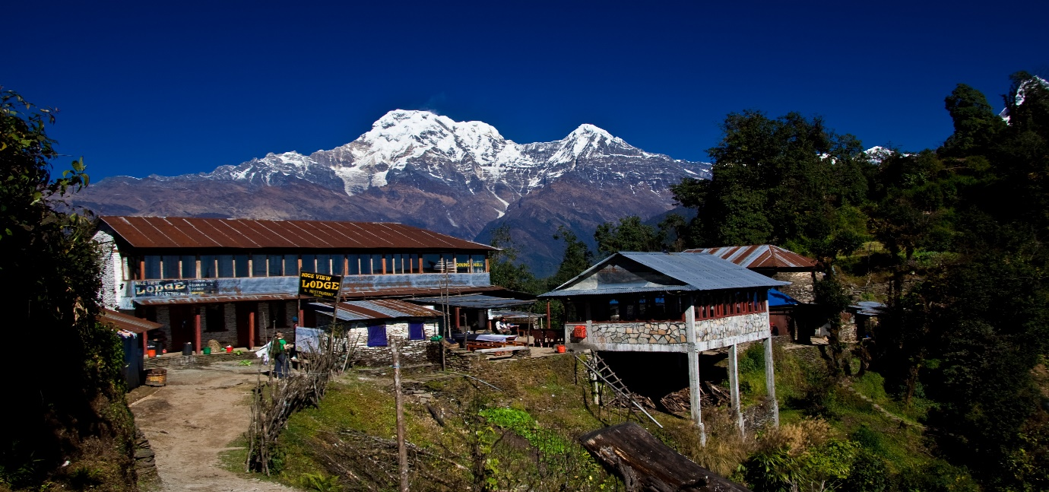

|  |
| --- |
| **Day 09: Trek Bamboo to Jhinu Danda (1,780 m / 6 hrs)** |

Trek through forests and steep steps to Jhinu Danda, famous for its **natural hot springs.**

**Overnight:** Stay at a teahouse in Jhinu  
**Meals:** Breakfast, Lunch, Dinner

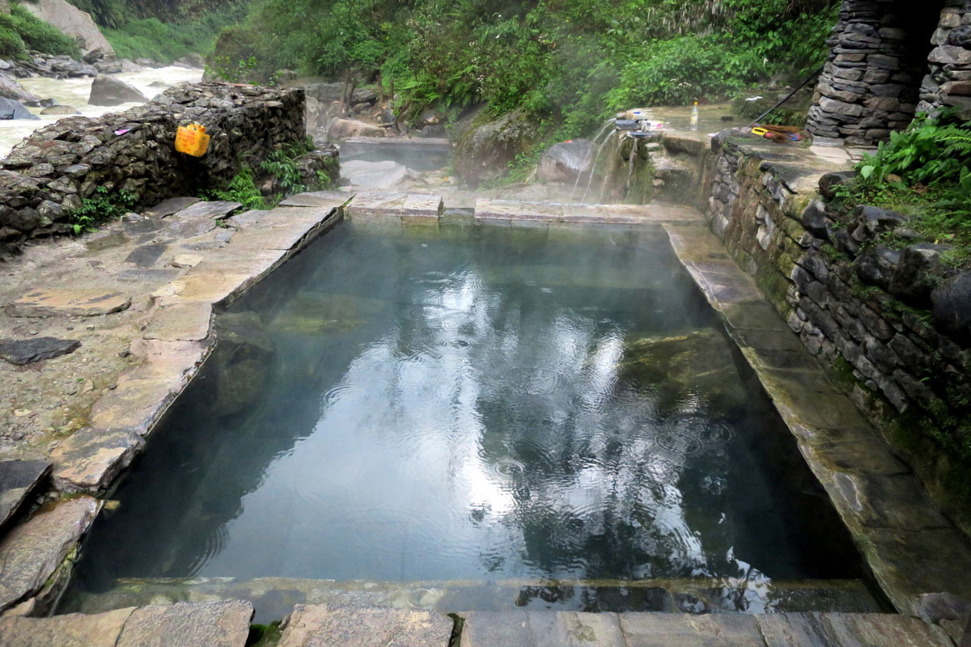

|  |
| --- |
| **Day 10: Trek Jhinu to Jhinu Bridge (1 hr) – Drive to Pokhara (3 hrs)** |

After a short trek to the bridge, meet your vehicle for a scenic drive back to Pokhara.  
Enjoy a well-earned rest by the lake or indulge in some souvenir shopping.

**Overnight:** Stay at Hotel, Pokhara  
**Meals:** Breakfast, Lunch

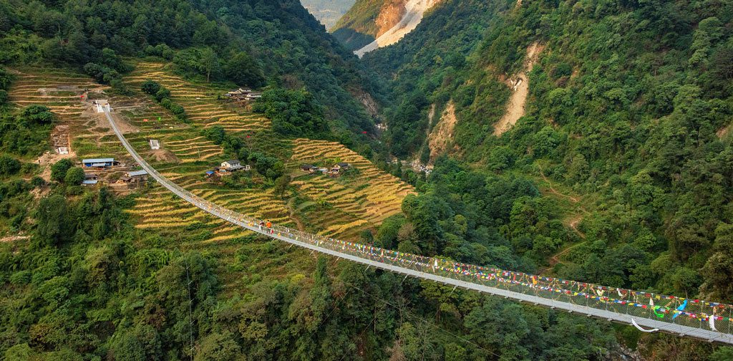

|  |
| --- |
| **Day 11: Fly Pokhara to Kathmandu** |

After breakfast, transfer to Pokhara airport for your flight back to Kathmandu.

After check-in hotel, visit to **Swyambhunath Stupa** (Monkey Temple), perched on a hilltop with sweeping views of the Kathmandu Valley.

Continue to the **Boudhanath Stupa**, a massive mandala and important pilgrimage site.

Visit the UNESCO-listed Kathmandu **Durbar Square**, **Kumari Ghar** (House of the Living Goddess).  
**Evening:** Return to the hotel for dinner and relax.

**Overnight:** Stay at Hotel Maya Manor Boutique, Kathmandu.

**Meals:** Breakfast, Dinner.

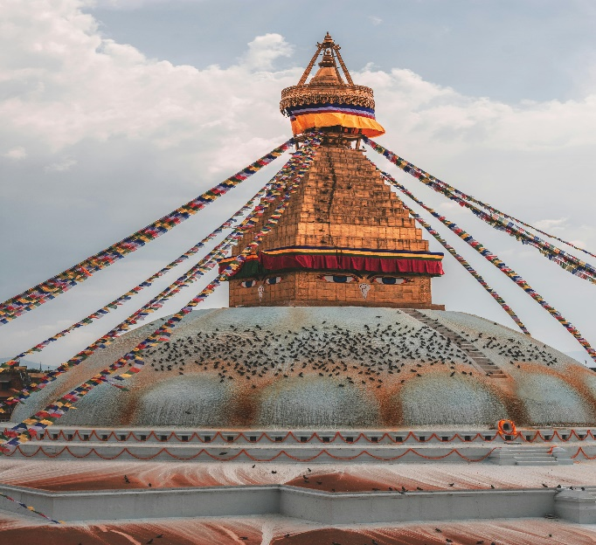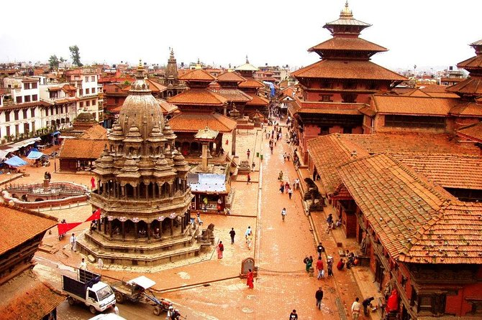

|  |
| --- |
| **Day 12: Departure** |

**Morning:** After breakfast, check out from the hotel.

You will be transferred to the airport in time for your onward flight.   
Our Representative will assist you in Check in and final farewell.  
**Meals:** Breakfast

**End of Services**

|  |
| --- |
| **Cost Of Package (B2B) : -** |

**Valid till 31st March 2026** (Except for 20th Dec’25 Till 5th Jan’26)

|  |  |
| --- | --- |
| **Minimum Paying Pax** | **Land Package Cost Per Person** |
| Min 02 Paying Pax on Double sharing basis | Euro |
| Min 04 Paying Pax on Double sharing basis | Euro |
| Min 06 Paying Pax on Double sharing basis | Euro |
| SGL Room Supplement | Euro |
| KTM/PKH/KTM Flight Fare Supplement | Euro |

|  |
| --- |
| **HOTEL ENVISAGED (or Similar)** |

|  |  |  |
| --- | --- | --- |
| **Place** | Hotel | **Nights** |
| **Kathmandu** | Maya Manor Boutique / Hotel Akama | 01 Night |
| **Pokhara** | Atithi Resort / Ladnmark / Mount Kailash | 01 Night |
| **Ghandruk** | Tea House | 01 Night |
| **Chhomorang** | Tea House | 01 Night |
| **Dovan** | Tea House | 01 Night |
| **Deurali** | Tea House | 01 Night |
| **ABC** | Tea House | 01 Night |
| **Bamboo** | Tea House | 01 Night |
| **Jhindu Danda** | Tea House | 01 Night |
| **Pokhara** | Atithi Resort / Ladnmark / Mount Kailash | 01 Night |
| **Kathmandu** | Maya Manor Boutique / Hotel Akama | 01 Night |

|  |
| --- |
| **ABOVE QUOTATION INCLUDES:** |

* Accommodation on Double sharing basis in Superior Hotels & in Tea Houses during Trekking for total of 11 nights.
* Meals: As mentioned in the itinerary
* All Arrival/ Departure Transfers, sightseeing & long drives by Air conditioned Car / MUV / VAN.
* Driver batta, fuel, parking & all interstate taxes.
* Services of Nepali National *German Speaking Trekking Guide* as per the itinerary.
* Porter on 2:1 basis during trekking.
* Annapurna conservation Area Permit (ACAP).
* TIMS permit fee
* Monument Entrance Charges as per city sightseeing mentioned in the itinerary
* Boat Ride at Fewa lake, Pokhara
* Dinner with Cultural Dance Show in Kathmandu.
* Masala Tea Experience during the Tour.
* Assistance on arrival and departure by Company representative.
* 01 bottle of mineral water per person during drives & City sightseeing.
* Traditional welcome with Garlanding at Kathmandu Airport upon arrival.
* All current applicable tax as on date.

|  |
| --- |
| **ABOVE COST DOES NOT INCLUDE:** |

* Any International / Domestic Airfare, Visa or Travel / Medical Insurance charges.
* Any kind of Tips or Gratitude for GUIDE, Driver, Hotel Staff, Porters etc.
* Personal expenses like drinks, laundry, telephone calls and porterage.
* Extra Baggage Charges
* Trekking equipment, Personal gears & clothing (available on hire)
* Battery Charging/ Drinking water and beverages.
* Liabilities due to loss of baggage, flight cancellation, and any extra cost involved due to Trans-shipment occurring due to road blocks etc.
* Any personal expenses.
* Any service which has not mentioned above.

|  |
| --- |
| **Important Notes:** |

1. There will be dormitory accommodation at the higher points of treks.
2. Heater is available at Dining area with extra cost.
3. You are travelling in environmentally sensitive area; use of plastic bottles is prohibited. Hence you need to carry your own water bottles or Thermos for your personnel use.   
   Hot & Cold water can be refilled at the lodge with extra cost of NPR.100-200 per refill.
4. Battery & Mobile charge can be negotiated with the owner of the lodge and can be paid directly.

* NEPAL OFFERS VISA ON ARRIVAL (with Fees applicable below)

15 Days – 30 USD

30 Days – 50 USD

Ein Bild, das Text, Schrift, Screenshot, Grafiken enthält.

For further information please contact: Keksconsulting KLG

Bierhausstrasse 28

CH-1712 Tafers

Phone: +41-76- 792-2427

info@keksconsulting.com